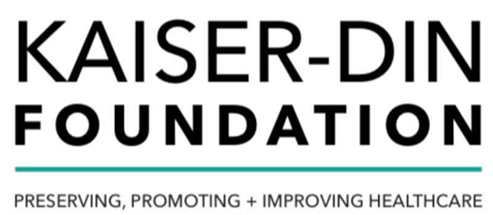

In keeping with the mission of the Kaiser-Din Foundation to preserve, promote, and improve the health and well-being of populations, communities, and individuals as it pertains to the field of medicine.

To fulfill this mission, we wish to foster the education of medicine, provide continuing education, promote public awareness, and promote public health. One of the goals of the Kaiser-Din foundation is to invest its resources to awarding a scholarship to a prospective podiatry student. The award will be based primarily on personal achievements, volunteerism, leadership, and community and service involvement. The applicant must be accepted to enroll in an accredited US Podiatry School for the 2020 academic year.
One of the major initiatives of the Kaiser-Din Foundation is to attract and support new students in podiatry by improving educational opportunities for prospective podiatry professionals through this scholarship. Scholarship award will be announced prior to the 2020 academic year.

Eligibility
To be eligible for this scholarship, applicants must meet the following criteria:
Must be accepted for enrollment in one of the U.S. Accredited Podiatry Schools for the August 2020-2021 Program:
- Arizona School of Podiatric Medicine at Midwestern University (AZPod)
- Barry University School of Podiatric Medicine (BUSPM)
- California School of Podiatric Medicine at Samuel Merritt University (CSPM)
- College of Podiatric Medicine and Surgery at Des Moines University (DMU-CPMS)
- Kent State University College of Podiatric Medicine (KSUCPM)
- New York College of Podiatric Medicine (NYCPM)
- Dr. William M. Scholl College of Podiatric Medicine at Rosalind Franklin University of Medicine and Science (SCPM)
- Temple University School of Podiatric Medicine (TUSPM)
- Western University of Health Sciences, College of Podiatric Medicine (WUCPM)
- Actively enrolled in a 4-year Doctorate of Podiatric Medicine (DPM) program towards pursuing a degree
- Completed at least 50 hours of community service
- Have not been awarded any Kaiser-Din Foundation scholarships for the academic degree being sought through this application.
- Apply to only one scholarship offered by Kaiser-Din Foundation in 2020 calendar year
- Submit an application and all of its components
Additional requirements are listed on the online scholarship application
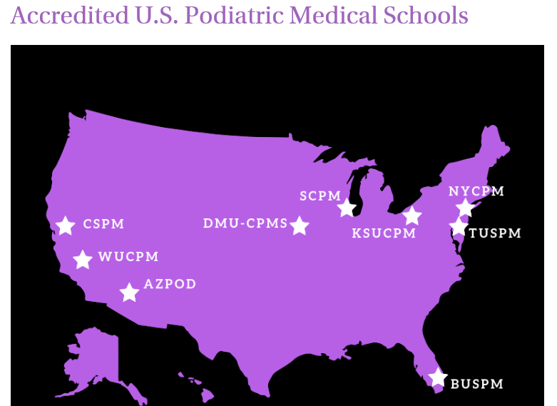

Application and Award Timeline
- Application Opens: May 15, 2020
Application Closes: June 15, 2020
- Award Notification Made After: July 1, 2020
Award will be sent directly to the School to be directly applied to tuition

Application Process
The application process will involve answering an essay question and verifying enrollment. The application will cover topics such as: academic history, career objectives, professional and volunteer experience, and educational and professional goals. The completed application with all attachments must be e-mailed to info@kaiserdinfoundation.com
Note: Mailed applications will not be accepted. And applications sent without supporting documents and attachments will not be accepted.

Review Criteria
Each eligible application will be reviewed by the Kaiser-Din Foundation Scholarship Committee. Applications will be evaluated based on the following:
- Volunteer, work and/or leadership experience;
- Honors, awards, or recognition such as but not limited to academic, volunteer, work, leadership;
- Commitment to the Podiatry profession;
- Acceptance into an accredited Podiatry School in the USA
- Essay clarity and completeness of thought including clear and concise sentences with proper use of grammar; and
- Completeness of application.

Available Scholarships
- $5000 Scholarship is available for the 2020 year
- Applicants are eligible to receive only one scholarship in a calendar year.

